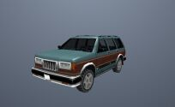
Vehicle ID: 400
Vehicle Name: Landstalker
Category: Off Road
Modifications: Trans Fender

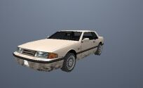
Vehicle ID: 401
Vehicle Name: Bravura
Category: Saloons
Modifications: Trans Fender

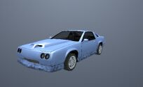
Vehicle ID: 402
Vehicle Name: Buffalo
Category: Sport Vehicles
Modifications: Transfender

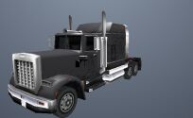
Vehicle ID: 403
Vehicle Name: Linerunner
Category: Industrial
Modifications: None

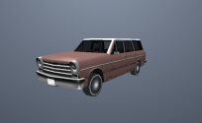
Vehicle ID: 404
Vehicle Name: Perenniel
Category: Station Wagons
Modifications: Trans Fender

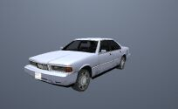
Vehicle ID: 405
Vehicle Name: Sentinel
Category: Saloons
Modifications: Trans Fender

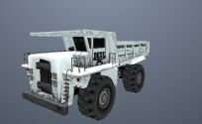
Vehicle ID: 406
Vehicle Name: Dumper
Category: Unique Vehicles
Modifications: None

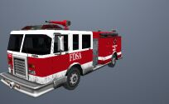
Vehicle ID: 407
Vehicle Name: Firetruck
Category: Public Service
Modifications: None

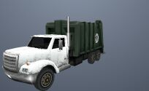
Vehicle ID: 408
Vehicle Name: Trashmaster
Category: Industrial
Modifications: None

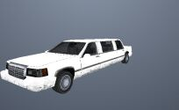
Vehicle ID: 409
Vehicle Name: Stretch
Category: Unique Vehicles
Modifications: Trans Fender

[AD] Vehicle ID: 410
Vehicle Name: Manana
Category: Saloons
Modifications: Trans Fender

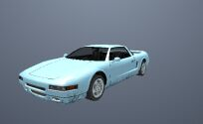
Vehicle ID: 411
Vehicle Name: Infernus
Category: Sport Vehicles
Modifications: Trans Fender

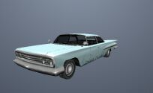
Vehicle ID: 412
Vehicle Name: Voodoo
Category: Lowriders
Modifications: Loco Low Co

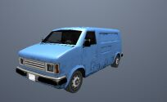
Vehicle ID: 413
Vehicle Name: Pony
Category: Industrial
Modifications: None

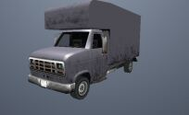
Vehicle ID: 414
Vehicle Name: Mule
Category: Industrial
Modifications: None

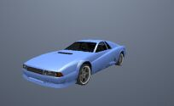
Vehicle ID: 415
Vehicle Name: Cheetah
Category: Sport Vehicles
Modifications: Trans Fender


Vehicle ID: 416
Vehicle Name: Ambulance
Category: Public Service
Modifications: None

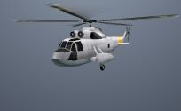
Vehicle ID: 417
Vehicle Name: Leviathan
Category: Helicopters
Modifications: None

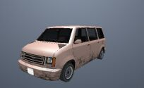
Vehicle ID: 418
Vehicle Name: Moonbeam
Category: Station Wagons
Modifications: Trans Fender

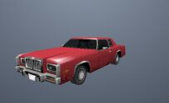
Vehicle ID: 419
Vehicle Name: Esperanto
Category: Saloons
Modifications: Trans Fender

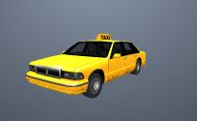
Vehicle ID: 420
Vehicle Name: Taxi
Category: Public Service
Modifications: Transfender

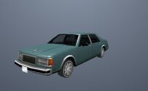
Vehicle ID: 421
Vehicle Name: Washington
Category: Saloons
Modifications: Trans Fender

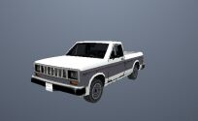
Vehicle ID: 422
Vehicle Name: Bobcat
Category: Industrial
Modifications: Trans Fender

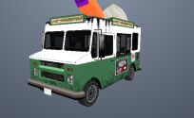
Vehicle ID: 423
Vehicle Name: Mr Whoopee
Category: Unique Vehicles
Modifications: None


Vehicle ID: 424
Vehicle Name: BF Injection
Category: Off Road
Modifications: Trans Fender

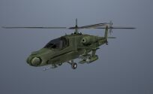
Vehicle ID: 425
Vehicle Name: Hunter
Category: Helicopters
Modifications: None

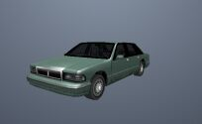
Vehicle ID: 426
Vehicle Name: Premier
Category: Saloons
Modifications: Trans Fender

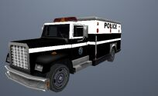
Vehicle ID: 427
Vehicle Name: Enforcer
Category: Public Service
Modifications: None

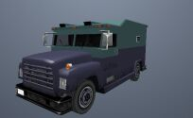
Vehicle ID: 428
Vehicle Name: Securicar
Category: Unique Vehicles
Modifications: None

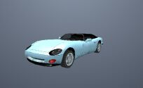
Vehicle ID: 429
Vehicle Name: Banshee Banger
Category: Sport Vehicles
Modifications: None

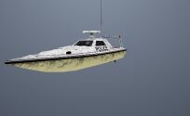
Vehicle ID: 430
Vehicle Name: Predator
Category: Boats
Modifications: None

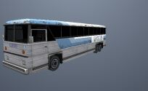
Vehicle ID: 431
Vehicle Name: Bus
Category: Public Service
Modifications: None

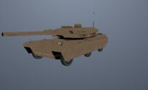
Vehicle ID: 432
Vehicle Name: Rhino
Category: Public Service
Modifications: None

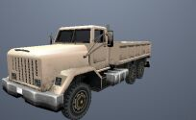
Vehicle ID: 433
Vehicle Name: Barracks
Category: Public Service
Modifications: None

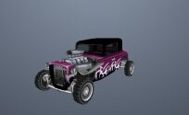
Vehicle ID: 434
Vehicle Name: Hotknife
Category: Unique Vehicles
Modifications: None


Vehicle ID: 435
Vehicle Name: Article Trailer
Category: Trailers
Modifications: None

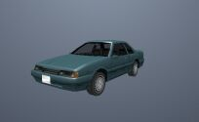
Vehicle ID: 436
Vehicle Name: Previon
Category: Saloons
Modifications: Trans Fender

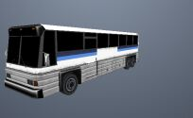
Vehicle ID: 437
Vehicle Name: Coach
Category: Public Service
Modifications: None

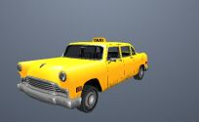
Vehicle ID: 438
Vehicle Name: Cabbie
Category: Public Service
Modifications: Transfender

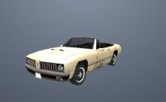
Vehicle ID: 439
Vehicle Name: Stallion
Category: Convertibles
Modifications: Trans Fender

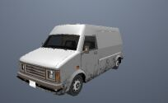
Vehicle ID: 440
Vehicle Name: Rumpo
Category: Industrial
Modifications: None


Vehicle ID: 441
Vehicle Name: RC Bandit
Category: RC Vehicles
Modifications: None

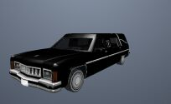
Vehicle ID: 442
Vehicle Name: Romero
Category: Unique Vehicles
Modifications: Trans Fender

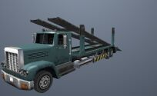
Vehicle ID: 443
Vehicle Name: Packer
Category: Industrial
Modifications: None

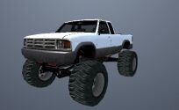
Vehicle ID: 444
Vehicle Name: Monster
Category: Off Road
Modifications: None

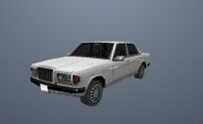
Vehicle ID: 445
Vehicle Name: Admiral
Category: Saloons
Modifications: Trans Fender

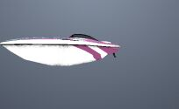
Vehicle ID: 446
Vehicle Name: Squallo
Category: Boats
Modifications: None

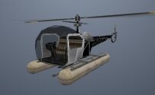
Vehicle ID: 447
Vehicle Name: Seasparrow
Category: Helicopters
Modifications: None

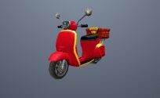
Vehicle ID: 448
Vehicle Name: Pizzaboy
Category: Bikes
Modifications: None

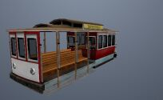
Vehicle ID: 449
Vehicle Name: Tram
Category: Unique Vehicles
Modifications: None

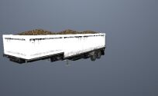
Vehicle ID: 450
Vehicle Name: Article Trailer 2
Category: Trailers
Modifications: None


Vehicle ID: 451
Vehicle Name: Turismo
Category: Sport Vehicles
Modifications: Trans Fender

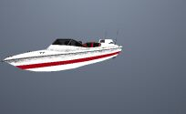
Vehicle ID: 452
Vehicle Name: Speeder
Category: Boats
Modifications: None

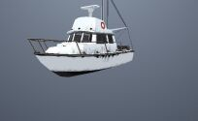
Vehicle ID: 453
Vehicle Name: Reefer
Category: Boats
Modifications: None


Vehicle ID: 454
Vehicle Name: Tropic
Category: Boats
Modifications: None

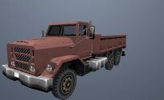
Vehicle ID: 455
Vehicle Name: Flatbed
Category: Industrial
Modifications: None

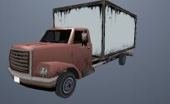
Vehicle ID: 456
Vehicle Name: Yankee
Category: Industrial
Modifications: None

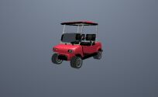
Vehicle ID: 457
Vehicle Name: Caddy
Category: Unique Vehicles
Modifications: None

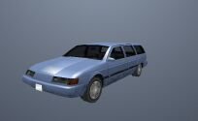
Vehicle ID: 458
Vehicle Name: Solair
Category: Station Wagons
Modifications: Trans Fender

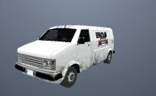
Vehicle ID: 459
Vehicle Name: Topfun
Category: Industrial
Modifications: None


Vehicle ID: 460
Vehicle Name: Skimmer
Category: Airplane
Modifications: None

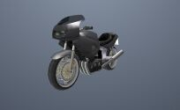
Vehicle ID: 461
Vehicle Name: PCJ-600
Category: Bikes
Modifications: None

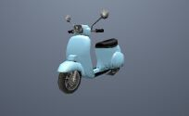
Vehicle ID: 462
Vehicle Name: Faggio
Category: Bikes
Modifications: None

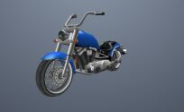
Vehicle ID: 463
Vehicle Name: Freeway
Category: Bikes
Modifications: None


Vehicle ID: 464
Vehicle Name: RC Baron
Category: RC Vehicles
Modifications: None

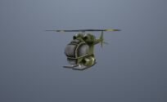
Vehicle ID: 465
Vehicle Name: RC Raider
Category: RC Vehicles
Modifications: None

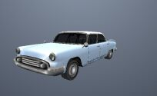
Vehicle ID: 466
Vehicle Name: Glendale
Category: Saloons
Modifications: Trans Fender

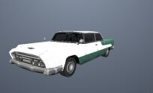
Vehicle ID: 467
Vehicle Name: Oceanic
Category: Saloons
Modifications: Trans Fender

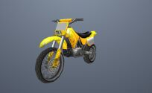
Vehicle ID: 468
Vehicle Name: Sanchez
Category: Bikes
Modifications: None

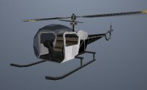
Vehicle ID: 469
Vehicle Name: Sparrow
Category: Helicopters
Modifications: None

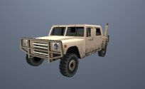
Vehicle ID: 470
Vehicle Name: Patriot
Category: Off Road
Modifications: None


Vehicle ID: 471
Vehicle Name: Quad
Category: Bikes
Modifications: None

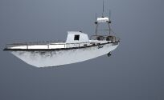
Vehicle ID: 472
Vehicle Name: Coastguard
Category: Boats
Modifications: None

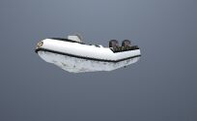
Vehicle ID: 473
Vehicle Name: Dinghy
Category: Boats
Modifications: None

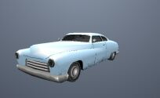
Vehicle ID: 474
Vehicle Name: Hermes
Category: Saloons
Modifications: Trans Fender

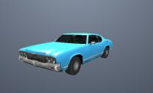
Vehicle ID: 475
Vehicle Name: Sabre
Category: Sport Vehicles
Modifications: Trans Fender

[AD] Vehicle ID: 476
Vehicle Name: Rustler
Category: Airplane
Modifications: None

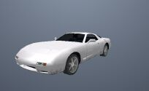
Vehicle ID: 477
Vehicle Name: ZR-350
Category: Sport Vehicles
Modifications: Trans Fender

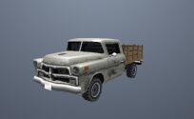
Vehicle ID: 478
Vehicle Name: Walton
Category: Industrial
Modifications: Trans Fender

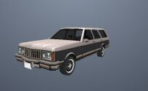
Vehicle ID: 479
Vehicle Name: Regina
Category: Station Wagons
Modifications: Trans Fender

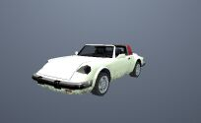
Vehicle ID: 480
Vehicle Name: Comet
Category: Convertibles
Modifications: Trans Fender


Vehicle ID: 481
Vehicle Name: BMX
Category: Bikes
Modifications: None

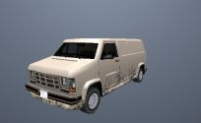
Vehicle ID: 482
Vehicle Name: Burrito
Category: Industrial
Modifications: None

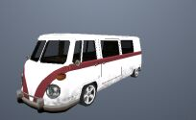
Vehicle ID: 483
Vehicle Name: Camper
Category: Unique Vehicles
Modifications: None

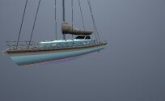
Vehicle ID: 484
Vehicle Name: Marquis
Category: Boats
Modifications: None

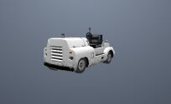
Vehicle ID: 485
Vehicle Name: Baggage
Category: Unique Vehicles
Modifications: None

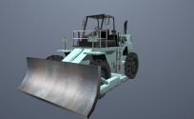
Vehicle ID: 486
Vehicle Name: Dozer
Category: Unique Vehicles
Modifications: None

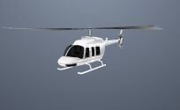
Vehicle ID: 487
Vehicle Name: Maverick
Category: Helicopters
Modifications: None

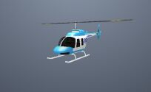
Vehicle ID: 488
Vehicle Name: San News Maverick
Category: Helicopters
Modifications: None

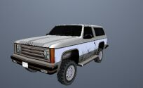
Vehicle ID: 489
Vehicle Name: Rancher
Category: Off Road
Modifications: Trans Fender

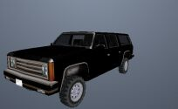
Vehicle ID: 490
Vehicle Name: FBI Rancher
Category: Public Service
Modifications: None

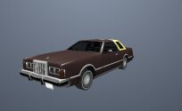
Vehicle ID: 491
Vehicle Name: Virgo
Category: Saloons
Modifications: Trans Fender

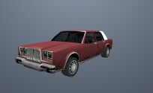
Vehicle ID: 492
Vehicle Name: Greenwood
Category: Saloons
Modifications: Trans Fender


Vehicle ID: 493
Vehicle Name: Jetmax
Category: Boats
Modifications: None

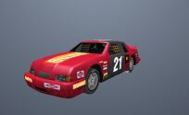
Vehicle ID: 494
Vehicle Name: Hotring Racer
Category: Sport Vehicles
Modifications: None

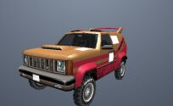
Vehicle ID: 495
Vehicle Name: Sandking
Category: Off Road
Modifications: None

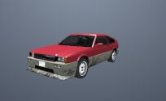
Vehicle ID: 496
Vehicle Name: Blista Compact
Category: Sport Vehicles
Modifications: Trans Fender

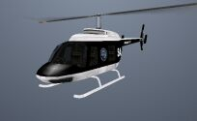
Vehicle ID: 497
Vehicle Name: Police Maverick
Category:
Modifications: None

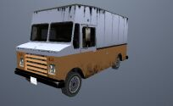
Vehicle ID: 498
Vehicle Name: Boxville
Category: Industrial
Modifications: None

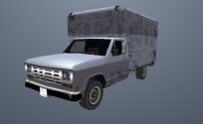
Vehicle ID: 499
Vehicle Name: Benson
Category: Industrial
Modifications: None

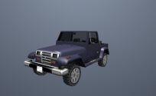
Vehicle ID: 500
Vehicle Name: Mesa
Category: Off Road
Modifications: Trans Fender

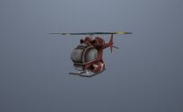
Vehicle ID: 501
Vehicle Name: RC Goblin
Category: RC Vehicles
Modifications: None

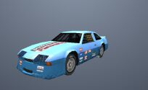
Vehicle ID: 502
Vehicle Name: Hotring Racer
Category: Sport Vehicles
Modifications: None

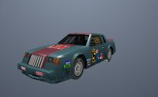
Vehicle ID: 503
Vehicle Name: Hotring Racer
Category: Sport Vehicles
Modifications: None

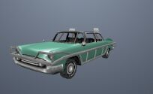
Vehicle ID: 504
Vehicle Name: Bloodring Banger
Category: Saloons
Modifications: None

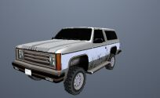
Vehicle ID: 505
Vehicle Name: Rancher
Category: Off Road
Modifications: Trans Fender

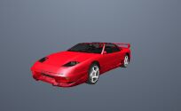
Vehicle ID: 506
Vehicle Name: Super GT
Category: Sport Vehicles
Modifications: Trans Fender

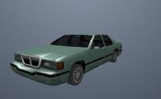
Vehicle ID: 507
Vehicle Name: Elegant
Category: Saloons
Modifications: Trans Fender

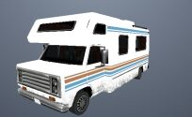
Vehicle ID: 508
Vehicle Name: Camper
Category: Unique Vehicles
Modifications: None


Vehicle ID: 509
Vehicle Name: Bike
Category: Bikes
Modifications: None


Vehicle ID: 510
Vehicle Name: Mountain Bike
Category: Bikes
Modifications: None

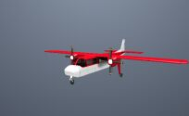
Vehicle ID: 511
Vehicle Name: Beagle
Category: Airplane
Modifications: None


Vehicle ID: 512
Vehicle Name: Cropduster
Category: Airplane
Modifications: None


Vehicle ID: 513
Vehicle Name: Stuntplane
Category: Airplane
Modifications: None

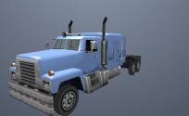
Vehicle ID: 514
Vehicle Name: Petrol Tanker
Category: Industrial
Modifications: None

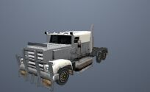
Vehicle ID: 515
Vehicle Name: Roadtrain
Category: Industrial
Modifications: None

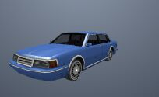
Vehicle ID: 516
Vehicle Name: Nebula
Category: Saloons
Modifications: Trans Fender

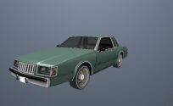
Vehicle ID: 517
Vehicle Name: Majestic
Category: Saloons
Modifications: Trans Fender

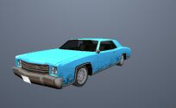
Vehicle ID: 518
Vehicle Name: Buccaneer
Category: Saloons
Modifications: Trans Fender


Vehicle ID: 519
Vehicle Name: Shamal
Category: Airplane
Modifications: None

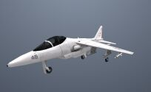
Vehicle ID: 520
Vehicle Name: Hydra
Category: Airplane
Modifications: None

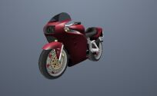
Vehicle ID: 521
Vehicle Name: FCR-900
Category: Bikes
Modifications: None


Vehicle ID: 522
Vehicle Name: NRG-500
Category: Bikes
Modifications: None

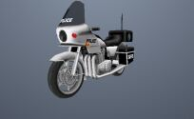
Vehicle ID: 523
Vehicle Name: Cop Bike HPV1000
Category: Public Service
Modifications: None

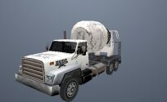
Vehicle ID: 524
Vehicle Name: Cement Truck
Category: Industrial
Modifications: None

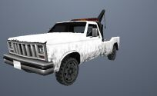
Vehicle ID: 525
Vehicle Name: Towtruck
Category: Unique Vehicles
Modifications: None

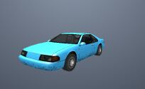
Vehicle ID: 526
Vehicle Name: Fortune
Category: Saloons
Modifications: Trans Fender

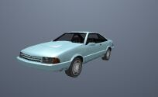
Vehicle ID: 527
Vehicle Name: Cadrona
Category: Saloons
Modifications: Trans Fender


Vehicle ID: 528
Vehicle Name: FBI Truck
Category: Public Service
Modifications: None

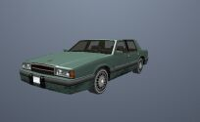
Vehicle ID: 529
Vehicle Name: Willard
Category: Saloons
Modifications: Trans Fender

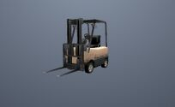
Vehicle ID: 530
Vehicle Name: Forklift
Category: Unique Vehicles
Modifications: None

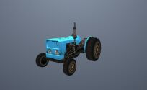
Vehicle ID: 531
Vehicle Name: Tractor
Category: Industrial
Modifications: None

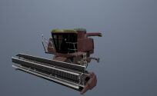
Vehicle ID: 532
Vehicle Name: Combine Harvester
Category: Unique Vehicles
Modifications: None

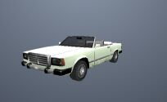
Vehicle ID: 533
Vehicle Name: Feltzer
Category: Convertibles
Modifications: Trans Fender

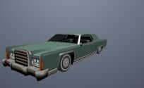
Vehicle ID: 534
Vehicle Name: Remington
Category: Lowriders
Modifications: Loco Low Co

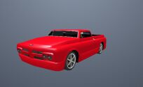
Vehicle ID: 535
Vehicle Name: Slamvan
Category: Lowriders
Modifications: Loco Low Co

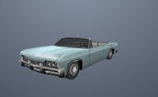
Vehicle ID: 536
Vehicle Name: Blade
Category: Lowriders
Modifications: Loco Low Co

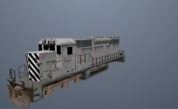
Vehicle ID: 537
Vehicle Name: Freight (Train)
Category: Unique Vehicles
Modifications: None

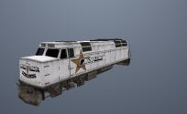
Vehicle ID: 538
Vehicle Name: Brownstreak (Train)
Category: Unique Vehicles
Modifications: None

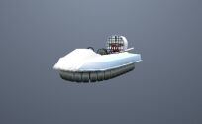
Vehicle ID: 539
Vehicle Name: Vortex
Category: Unique Vehicles
Modifications: None

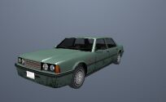
Vehicle ID: 540
Vehicle Name: Vincent
Category: Saloons
Modifications: Trans Fender

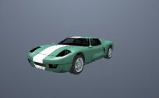
Vehicle ID: 541
Vehicle Name: Bullet
Category: Sport Vehicles
Modifications: Trans Fender

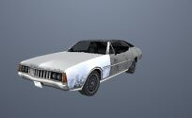
Vehicle ID: 542
Vehicle Name: Clover
Category: Saloons
Modifications: Trans Fender

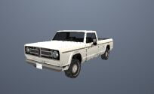
Vehicle ID: 543
Vehicle Name: Sadler
Category: Industrial
Modifications: None

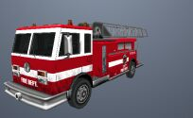
Vehicle ID: 544
Vehicle Name: Firetruck
Category: Public Service
Modifications: None


Vehicle ID: 545
Vehicle Name: Hustler
Category: Unique Vehicles
Modifications: Trans Fender

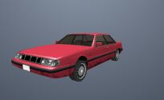
Vehicle ID: 546
Vehicle Name: Intruder
Category: Saloons
Modifications: Trans Fender

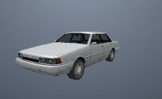
Vehicle ID: 547
Vehicle Name: Primo
Category: Saloons
Modifications: Trans Fender

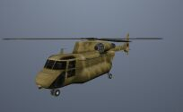
Vehicle ID: 548
Vehicle Name: Cargobob
Category: Helicopters
Modifications: None

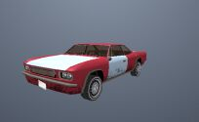
Vehicle ID: 549
Vehicle Name: Tampa
Category: Saloons
Modifications: Trans Fender

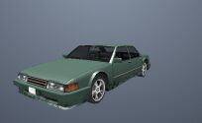
Vehicle ID: 550
Vehicle Name: Sunrise
Category: Saloons
Modifications: Trans Fender

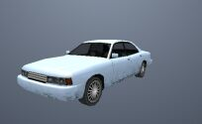
Vehicle ID: 551
Vehicle Name: Merit
Category: Saloons
Modifications: Trans Fender

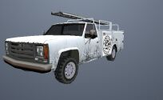
Vehicle ID: 552
Vehicle Name: Utility Van
Category: Industrial
Modifications: None

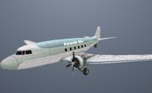
Vehicle ID: 553
Vehicle Name: Nevada
Category: Airplane
Modifications: None

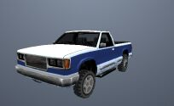
Vehicle ID: 554
Vehicle Name: Yosemite
Category: Industrial
Modifications: None

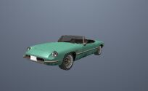
Vehicle ID: 555
Vehicle Name: Windsor
Category: Convertibles
Modifications: Trans Fender

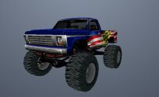
Vehicle ID: 556
Vehicle Name: Monster "A"
Category: Off Road
Modifications: None

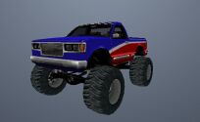
Vehicle ID: 557
Vehicle Name: Monster "B"
Category: Off Road
Modifications: None

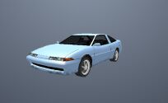
Vehicle ID: 558
Vehicle Name: Uranus
Category: Sport Vehicles
Modifications: Wheel Arch Angels

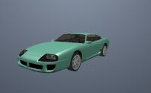
Vehicle ID: 559
Vehicle Name: Jester
Category: Sport Vehicles
Modifications: Wheel Arch Angels

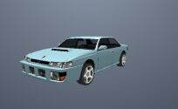
Vehicle ID: 560
Vehicle Name: Sultan
Category: Saloons
Modifications: Wheel Arch Angels

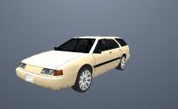
Vehicle ID: 561
Vehicle Name: Stratum
Category: Station Wagons
Modifications: Wheel Arch Angels

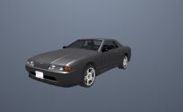
Vehicle ID: 562
Vehicle Name: Elegy
Category: Saloons
Modifications: Wheel Arch Angels

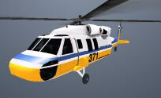
Vehicle ID: 563
Vehicle Name: Raindance
Category: Helicopters
Modifications: None


Vehicle ID: 564
Vehicle Name: RC Tiger
Category: RC Vehicles
Modifications: None

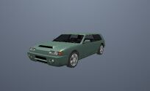
Vehicle ID: 565
Vehicle Name: Flash
Category: Sport Vehicles
Modifications: Wheel Arch Angels

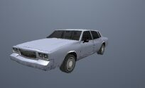
Vehicle ID: 566
Vehicle Name: Tahoma
Category: Lowriders
Modifications: Loco Low Co

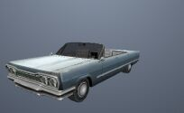
Vehicle ID: 567
Vehicle Name: Savanna
Category: Lowriders
Modifications: Loco Low Co

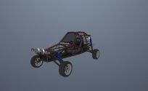
Vehicle ID: 568
Vehicle Name: Bandito
Category: Off Road
Modifications: None

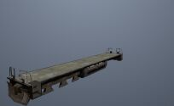
Vehicle ID: 569
Vehicle Name: Freight Flat Trailer (Train)
Category: Trailers
Modifications: None

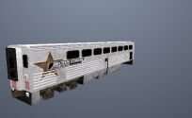
Vehicle ID: 570
Vehicle Name: Streak Trailer (Train)
Category: Trailers
Modifications: None


Vehicle ID: 571
Vehicle Name: Kart
Category: Unique Vehicles
Modifications: None

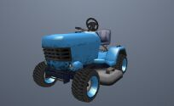
Vehicle ID: 572
Vehicle Name: Mower
Category: Unique Vehicles
Modifications: None

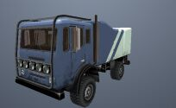
Vehicle ID: 573
Vehicle Name: Dune
Category: Off Road
Modifications: None

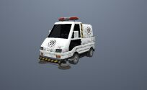
Vehicle ID: 574
Vehicle Name: Sweeper
Category: Unique Vehicles
Modifications: None

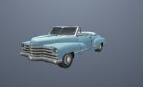
Vehicle ID: 575
Vehicle Name: Broadway
Category: Lowriders
Modifications: Trans Fender

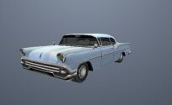
Vehicle ID: 576
Vehicle Name: Tornado
Category: Lowriders
Modifications: Loco Low Co

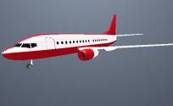
Vehicle ID: 577
Vehicle Name: AT400
Category: Airplane
Modifications: None

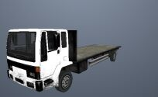
Vehicle ID: 578
Vehicle Name: DFT-30
Category: Industrial
Modifications: None

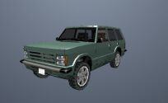
Vehicle ID: 579
Vehicle Name: Huntley
Category: Off Road
Modifications: Trans Fender

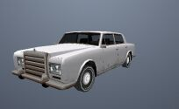
Vehicle ID: 580
Vehicle Name: Stafford
Category: Saloons
Modifications: Trans Fender

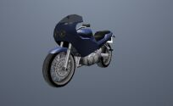
Vehicle ID: 581
Vehicle Name: BF-400
Category: Bikes
Modifications: None

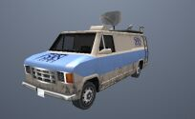
Vehicle ID: 582
Vehicle Name: Newsvan
Category: Industrial
Modifications: None

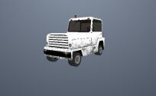
Vehicle ID: 583
Vehicle Name: Tug
Category: Unique Vehicles
Modifications: None

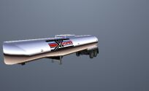
Vehicle ID: 584
Vehicle Name: Petrol Trailer
Category: Trailers
Modifications: None

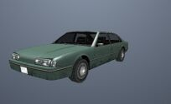
Vehicle ID: 585
Vehicle Name: Emperor
Category: Saloons
Modifications: Trans Fender

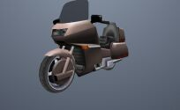
Vehicle ID: 586
Vehicle Name: Wayfarer
Category: Bikes
Modifications: None

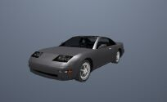
Vehicle ID: 587
Vehicle Name: Euros
Category: Sport Vehicles
Modifications: Wheel Arch Angels

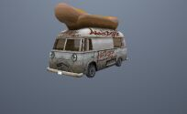
Vehicle ID: 588
Vehicle Name: Hotdog
Category: Unique Vehicles
Modifications: None

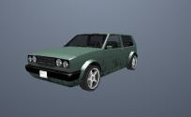
Vehicle ID: 589
Vehicle Name: Club
Category: Sport Vehicles
Modifications: Trans Fender

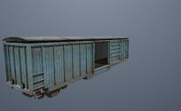
Vehicle ID: 590
Vehicle Name: Freight Box Trailer (Train)
Category: Trailers
Modifications: None

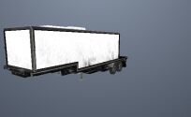
Vehicle ID: 591
Vehicle Name: Article Trailer 3
Category: Trailers
Modifications: None

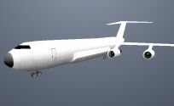
Vehicle ID: 592
Vehicle Name: Andromada
Category: Airplane
Modifications: None


Vehicle ID: 593
Vehicle Name: Dodo
Category: Airplane
Modifications: None


Vehicle ID: 594
Vehicle Name: RC Cam
Category: RC Vehicles
Modifications: None

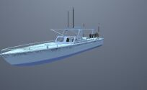
Vehicle ID: 595
Vehicle Name: Launch
Category: Boats
Modifications: None


Vehicle ID: 596
Vehicle Name: Police Car (LSPD)
Category: Public Service
Modifications: None


Vehicle ID: 597
Vehicle Name: Police Car (SFPD)
Category: Public Service
Modifications: None


Vehicle ID: 598
Vehicle Name: Police Car (LVPD)
Category: Public Service
Modifications: None

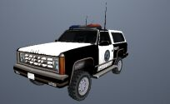
Vehicle ID: 599
Vehicle Name: Ranger
Category: Public Service
Modifications: None

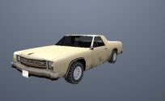
Vehicle ID: 600
Vehicle Name: Picador
Category: Saloons
Modifications: Trans Fender

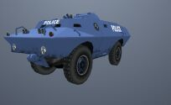
Vehicle ID: 601
Vehicle Name: S.W.A.T.
Category: Public Service
Modifications: None

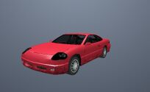
Vehicle ID: 602
Vehicle Name: Alpha
Category: Sport Vehicles
Modifications: Trans Fender

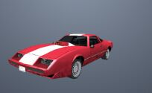
Vehicle ID: 603
Vehicle Name: Phoenix
Category: Sport Vehicles
Modifications: Trans Fender

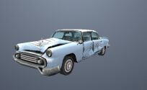
Vehicle ID: 604
Vehicle Name: Glendale Shit
Category: Saloons
Modifications: None

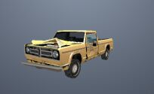
Vehicle ID: 605
Vehicle Name: Sadler Shit
Category: Industrial
Modifications: None

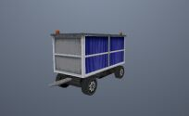
Vehicle ID: 606
Vehicle Name: Baggage Trailer "A"
Category: Trailers
Modifications: None

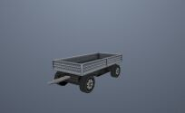
Vehicle ID: 607
Vehicle Name: Baggage Trailer "B"
Category: Trailers
Modifications: None

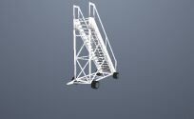
Vehicle ID: 608
Vehicle Name: Tug Stairs Trailer
Category: Trailers
Modifications: None

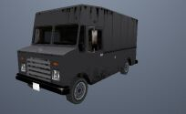
Vehicle ID: 609
Vehicle Name: Boxburg
Category: Industrial
Modifications: None

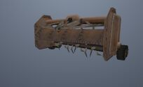
Vehicle ID: 610
Vehicle Name: Farm Trailer
Category: Trailers
Modifications: None

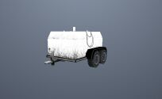
Vehicle ID: 611
Vehicle Name: Utility Trailer
Category: Trailers
Modifications: None

